**Title of paper (12 Point TNR, bold)**

**Author11**, **Author21** and **Author31* (10 Point TNR, bold)**

1Department of Mechanical Engineering, Indian Institute of Technology Madras, Chennai, Tamil Nadu, 600036 (10 Point TNR, unbold)

*Corresponding author Mail ID: [abc@iitm.ac.in](mailto:abc@iitm.ac.in) (10 Point TNR, unbold)

**Abstract (10 Point TNR, Bold)**

Write your abstract here in 10 point Times New Roman with 1.15 line spacing. Limit the abstract within 250 words.

**Keywords:** 4-5 words. (10 Point TNR, unbold)

# Introduction (10 Point TNR, Bold)

Times New Roman : font size : 11 : Line spacing : 1.15.

# Experimental/Numerical Methodology (10 Point TNR, Bold)

This subsection should contain the literature review and the objective of the work undertaken Write text matter here in 10 point Times New Roman, unbold and 1.15 line spacing. Necessary citations may be bracketed [5-8] appropriately.

|  |  |
| --- | --- |
|  | (1) |
|  | (2) |

# 3. Result and discussion (10 Point TNR, Bold)

Write your texts here in 10 point Times New Roman, unbold and 1.15 line spacing. This part should contain the necessary matters related to computational, experimental and analytical investigations. Necessary citations may be bracketed [9, 10] appropriately. All Figures / Tables are to be cited within the texts. The Figure/Table captions must be written in TNR 10 point, bold as indicated below. The Figure caption should appear at the bottom of the Figure, while the Table caption should appear on top of the Table. This is the standard practice.

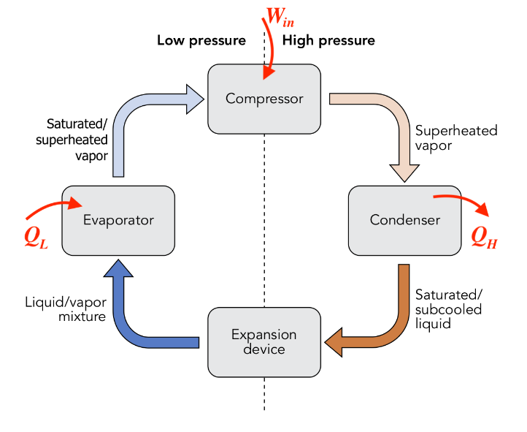

**Fig. 1:** Sample Figure (Schematic of set-up). (10 Point TNR)

* 1. **Subtitle** (Subtitles should be 10 point TNR).

Write text matter here in 10 point Times New Roman, unbold. All Figures are to be cited within the texts.

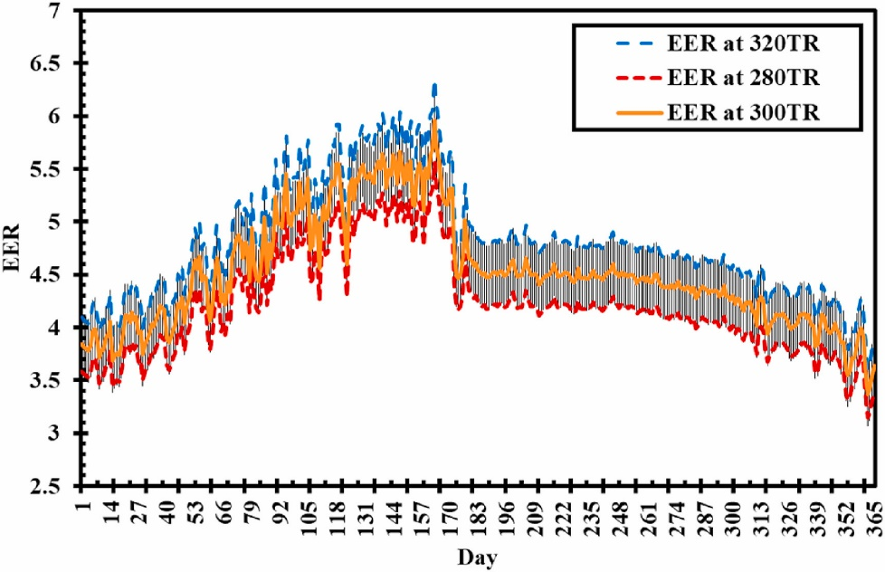

**Fig. 2:** EER variation over 365 days. (10 Point TNR)

**Table 1:** Sample table. (10 Point TNR)

|  |  |
| --- | --- |
| Independent Variables | Accuracy |
| Combined Rotor torque (*Trotor*) |  |
| Angular velocity of combined rotor $(ω$) | $$±2\%$$ |

(As indicated above, all the notations are to be italicized and be written in 10 Point Times New Roman, unbold and 1.15 line spacing)

# 4. Conclusions (10 Point TNR, Bold)

The key findings of the work are to be placed here in 10 point Times New Roman, unbold and 1.15 line spacing. The conclusion part should be qualitative and quantitative.

**Acknowledgements (10 Point TNR, Bold)**

Place any acknowledgements here in 10 point Times New Roman, unbold and 1.15 line spacing.

**Nomenclature (10 Point TNR, Bold)**

|  |  |  |  |  |  |
| --- | --- | --- | --- | --- | --- |
| *A* | area of the copper pipe | [m2] | EER | Energy Efficiency Ratio | -- |
| *AR* | aspect ratio | -- | *α* | LiBr concentration | (kgLiCl/kgsol.) |
| *COP* | coefficient of performance | -- | *ρ* | density of air | [kg/m3] |
| *TNR* | times new roman |  | *ω* | specific humidity | [gwv/kgda] |

(As indicated above, all the notations are to be italicized and be written in 10 Point Times New Roman, unbold)

**References**

1. K.M. Arun, S. Tiwari, A. Mani, Three-dimensional numerical investigations on rectangular cross-section ejector, Int. J. Therm. Sci. 122 (2017) 257–265.

<https://doi.org/10.1016/j.ijthermalsci.2017.08.024>.

1. J. V Herrera, O. García-Valladares, V.H. Gómez, R. Best, Numerical simulation and experimental results of horizontal tube falling film generator working in a NH3–LiNO3 absorption refrigeration system, Appl. Therm. Eng. 30 (2010) 1751–1763.

<https://doi.org/https://doi.org/10.1016/j.applthermaleng.2010.04.006>.

1. M. Maria Antony Raj, K. Kalidasa Murugavel, T. Rajaseenivasan, K. Srithar, A review on flash evaporation desalination, Desalin. Water Treat. 57 (2016) 13462–13471.

<https://doi.org/10.1080/19443994.2015.1070283>.

**Notes to Author(s):**

* The minimum page limit is 6 pages.
* The page limit of a paper is restricted to a maximum of 12 pages.
* In each section, sub-sectioning if required, can be done appropriately.
* Once the paper is compiled, remove all the instructions marked BLUE in this template.
* Also remove this part of Notes to Author(s).